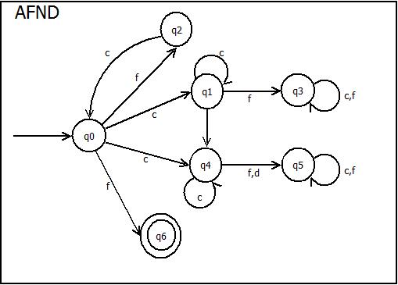**Tabla de Transición AFND**

|  |  |  |  |
| --- | --- | --- | --- |
|  | **c** | **f** | **d** |
| **→q0** | q1q4 | q2q6 | _ |
| **q1** | q1 | q3 | q4 |
| **q2** | q0 | _ | _ |
| **q3** | q3 | q3 | _ |
| **q4** | q4 | q5 | q5 |
| **q5** | q5 | q5 | _ |
| **\*q6** | _ | _ | _ |

**Tabla de Transición (Faltantes)**

|  |  |  |  |
| --- | --- | --- | --- |
|  | **c** | **f** | **d** |
| **q1q4** | q1q4 | q3q5 | q4q5 |
| **\*q2q6** | q0 | _ | _ |
| **q3q5** | q3q5 | q3q5 | _ |
| **q4q5** | q4q5 | q5 | q5 |

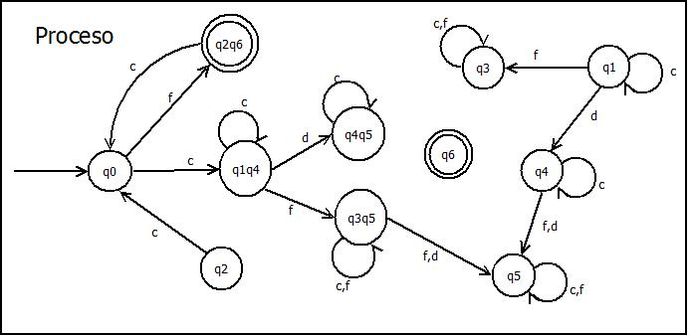

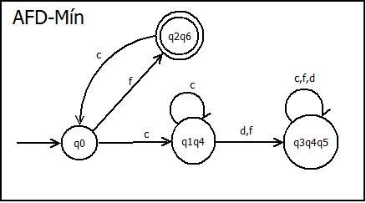 **Token de Prueba**

|  |  |
| --- | --- |
| **No** | **Yes** |
| **c** | **f** |
| **c…cf** | **fc** |
| **cccc…c** | **fcfc…f** |
| **D** |  |
| **cdf** |  |
| **ffff…f** |  |